# Task 10.2.4

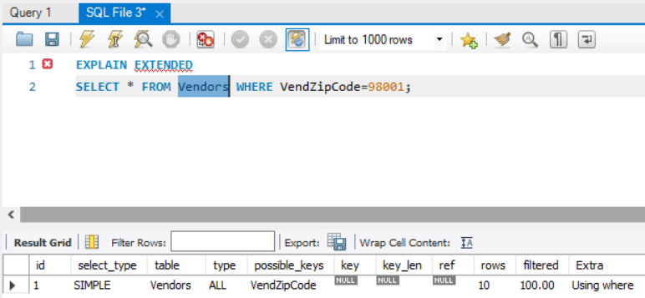

In this query database engine is going through each row sequentially and performing operation because type is ALL and that is why it has to go all 10 rows of vendors table to find a row(s) matching given where clause.